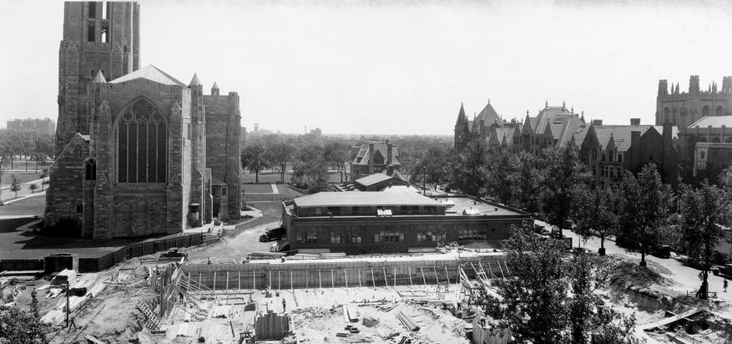

Right click on this photo and ‘Change Picture’

EVENT TITLE

DAY, MONTH, DATE
00:00-00:00 p.m. OR a.m.
Location
Registration required oi.uchicago.edu/register
$xx members $xx non-members

Lorem ipsum dolor sit amet, eu risus, varius sociosqu faucibus, nullam ultrices semper non sit vitae nibh. Dignissim et nunc reprehenderit justo proin nisl, augue tincidunt pharetra cras integer suspendisse ac, scelerisque blandit, non hymenaeos erat.

Adipiscing nulla nunc magna ut, pede ante, id purus dolor vivamus in, nulla dui volutpat morbi, ac imperdiet integer eu.
DAY, MONTH, DATE
00:00-00:00 p.m. OR a.m.
Location
Registration required oi.uchicago.edu/register
$xx members $xx non-members

Lorem ipsum dolor sit amet, eu risus, varius sociosqu faucibus, nullam ultrices semper non sit vitae nibh. Dignissim et nunc reprehenderit justo proin nisl, augue tincidunt pharetra cras integer suspendisse ac, scelerisque blandit, non hymenaeos erat.

Adipiscing nulla nunc magna ut, pede ante, id purus dolor vivamus in, nulla dui volutpat morbi, ac imperdiet integer eu.

